Technical Study - PT5201 Black Burst Sync Generator
Prepared by: NBe.

Contents

1 Introduction 2
2 User Interface 2
3 Mechanical Design/Styling 2
4 Technical Description 2
4.1 Main Instrument Functions 2
4.2 Instrument Block Diagram 3
4.3 Description of Instrument Block Diagram 3
4.4 SPG & Genlock 4
4.4.1 Main Functions 4
4.4.2 Block Diagram 4
4.4.3 Block Diagram Description 4
4.5 Master Controller 4
4.5.1 Main Functions 4
4.5.2 Block Diagram 5
4.5.3 Block Diagram Description 5
4.6 Black Burst Generators 6
4.6.1 Main Functions 6
4.6.2 Block Diagram 6
4.6.3 Block Diagram Description 7
4.7 Color Bar Generator – Analog & SDI 7
4.7.1 Main Functions, HW 7
4.7.2 Block Diagram, HW 8
4.7.3 Block Diagram Description, HW 8
4.7.4 Main Functions, SW 8
4.7.5 Block Diagram, SW 9
4.7.6 Block Diagram Description, SW 9
4.8 AES/EBU Generator 9
4.8.1 Main Functions 9
4.8.2 Block Diagram 10
4.8.3 Block Diagram Description 10
4.9 Remote interface 10
4.9.1 Main Functions 10
4.9.2 Block Diagram 10
4.9.3 Block Diagram Description 10
4.10 PC Remote Software 10
4.10.1 Main Functions 11
4.10.2 Block Diagram 11
4.10.3 Block Diagram Description 11
4.11 Power supply 11
4.12 Cabinet & Mechanics 11
4.13 New Components and Technologies 11
4.14 Development Time & Cost 12
4.15 Test equipment Time & Cost 12
4.16 Production Cost 12
5 Appendix 1 - Front & Rear plate layout 14
6 Appendix 2 - Estimate of development and production cost 15

Introduction
This document is prepared for the Study Review 1999-12-01 on PT 5201 Black Burst Sync Generator. It presents the results of a short study phase on a different type of an instrument than the normal PTV family. Investigations have been carried out to find out the consequences developing a small and very simple sync pulse generator to be sold to small studios in high volume.

The project kick-off took place 1999-11-08, so not all of the normal subjects to perform during a study phase have been treated. The target of the project: delivering a model for the NAB exhibition April 2000, requires that all effort is focussed on this and that our experience to a high extend is to be implemented directly in a product.

User Interface
Hvordan præsenterer produktet sig for brugeren rent betjenings mæssigt? Skitsér for- og bagpladen, og beskriv hvordan apparatet skal forbindes til “omverdenen”. Beskriv hvordan apparatet betjenes i alle situationer
Please refer to the preliminary data sheet for a description and to drawings showing front and rear plate layout in appendix 1.
In short the user interface consists of only LED’s on the front plate and an RS232 interface which connected to a PC with dedicated SW for PT 5201 enables the user to make all configuration and readout of status information via the PC.
The SW will be delivered together with the manual on a CD-ROM.
Signal interfacing is via standard type BNC and XLR connectors and normal electrical specifications are foreseen.

Mechanical Design/Styling
Hvordan ser apparatet ud? Størrelse og vægt? Anvendte farver, knapper og displays? Passer det design mæssigt med andre PTV (eller andre) apparater, det må forventes, det skal kunne arbejde sammen med?
Please also refer to the preliminary data sheet.
In short: ½ 19” *1U rack mountable.
Easy and cheap to produce, few and simple parts. No money spent on extravagance. But the basic quality must be OK. This is a new way to go, but fits well with the target customer who are more aware of prize and basic functions than of exclusive looks.
Internally the design will be based on one “large” PCB including if possible all connectors and LED´s. This is to minimize the cost of the electronics by removing the extra overhead several separate modules would generate.
The power supply will be internal with detachable standard mains cable.

Technical Description
Beskrivelse af apparatet og de anvendte kredsløb på - mindst - blok-diagram-niveau.
The PT 5201 will where possible be based on circuits and experience gained from PT 5210, PT 5230, and the pre-work done on PT 5220, but an intensive cost reduction by introduction of the most feasible components and methods will take place.
Where possible advantage will be taken of leaving out the normally required flexibility. The many options of PT 5210 and PT 5230 are deliberately excluded here and only ONE fixed version is planned.
To keep cost lowest possible the following features known from PT 5210 and PT 5230 have been changed:
- Level detectors on all outputs removed
- EDH is not inserted in SDI output
This is believed to be acceptable for the small studios.
The hard copy manual is replaced by a file on a CD-ROM (together with remote control SW).
The design will furthermore be optimized for production in larger quantities than normal for PTV. Few parts, easy mountable and extended automated test. No over-specification if it costs.

Main Instrument Functions
3 timeable Black Burst output
1 SDI Black Burst or Color Bar output
1 Genlock input, looped through, for synchronization to external Black Burst or 10 MHz reference.
1 AES/EBU output
1 AES/EBU WordClock
Multi-standard G/M
All configuration and user operation take place via an RS 232 remote interface connected to a PC with PTV SW
Front LED’s: Power on, Genlock signal missing, Error/warning, Indication of selected system G/M.
Mains operable with internal power supply: 90-250Vac input voltage range.

Instrument Block Diagram

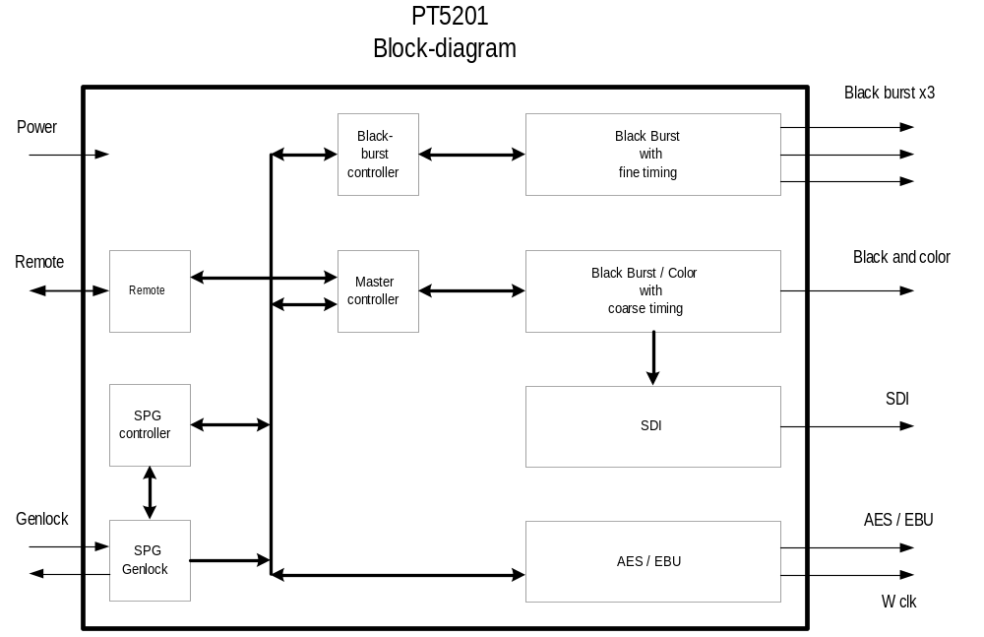

Description of Instrument Block Diagram
Prepared by TSc

- The 3 black burst generators are designed with one PLD (FLEX6016A) and one controller (XA). The PLD handles the signal generations and the controller handles the signal-type, the timing and the communication with the master-controller. This solution is chosen to meet the cost requirements since DSP, other PLD and multiplier solutions will increase the costs.
- The SDI and analog color/black generator and the AES / EBU generator will use only one PLD MAX7256 or similar to make these generators more cost efficient. The control functions are handled by the master-controller.
- The remote control uses an RS232 interface.
- The SPG handles the genlock function both external and internal and makes all the sync-signals and the master oscillator reference for the PT5201.
- The Master controller’s main purpose is to handle the user interface communication with the apparatus, (through an RS232 interface), i.e. to distribute user-settings/status to/from the distributed processor-systems handling the black burst generators and SPG&Genlock function. It furthermore handles the color bar/black-generator functions.

SPG & Genlock
Prepared by TSc

Main Functions

Block Diagram

Block Diagram Description

Master Controller
Prepared by KEn.

Main Functions
The main purpose of the software in the master controller is to handle the user interface communication with the apparatus, (through an RS232 interface), i.e. to distribute user-settings/status to/from the distributed processor-systems handling the black burst generators and SPG&Genlock function.

The secondary purpose of the software is to generate the control signals to the Color Bar–Analog&SDI generator. This function is integrated into the software as a separate task, thereby separating the generator function logically from the user interface function. As this function logically constitutes a stand alone processor-system, the software should also distribute user-settings/status to/from this function.

The user interface communication is rather static, i.e. it uses either no or very little resources when the user interface is idle as it probably will be in most cases. This also applies to the distribution of the user-settings to the distributed processor-systems. The only truly dynamic tasks are therefore the reception of status from the processor-systems, i.e. the apparatus ”health” condition, and the generation of the Color Bar control signals.

Implementation of these functions is well suited for an RTOS, if none of the tasks are time critical as compared to the time the RTOS uses for its implementation of the multitasking environment, e.g. if the worst case time required to handle an real-time interrupt in the multitasking environment is 100 ms, all signals which must be handled within 100ms or less, could not be implemented. It is however possible to suspend the multitasking environment shortly, in order to overcome the restriction of the above real-time interrupt handling. This suspension will however have the following impact on the multitasking environment; first the real-time is no longer real-time in respect to any tasks which must be performed/delayed by an RTOS timer, i.e. this time will be slowed down. Secondly if any real-timer interrupt is continuos, it must leave enough room for the RTOS to perform it’s normal functions, i.e. if an interrupt utilizes 90% of the time for it’s own purpose, only 10% of the time is available for the RTOS.

The HW configuration of the master controller has been determined due to cost, availability and the short time available to develop the apparatus, hence it is based on a XA controller configuration already known from the PT5210/30 series. This configuration runs at 30MHz and an RTOS is available in–house, (namely RTXC). The task of generating control signals to the Color Bar generator requires the XA controller to be interrupted every 64μs, (see description of Color Bar generator – Analog&SDI below). This timing requires the interrupt to be implemented outside the multitasking environment, as the worst case time to handle an interrupt is 91μs, (in a 20MHz system). Preliminary tests have shown that the 64μs interrupt is somewhat time consuming, but at this time it is not possible to give an estimate upon the time needed in the interrupt function to handle the generation of control signals for the Color Bar generator. A small amount of time, app.10μs, is necessary to enter and leave an interrupt routine, i.e. this time is necessary but is only an unwanted overhead.

In short, the HW implementation of the master controller, i.e. specifically the implementation of the control signals to the Color Bar generator, makes it very difficult to implement an RTOS, (i.e. RTXC), into the master controller software. If the RTOS is to be implemented in the apparatus in the above HW configuration, no guarantees can be made about the implementation of the RTOS, i.e. it constitutes a considerable risk. It must be considered that an extra microcontroller could be implemented in order to utilize the RTOS. It should also be noted the RTOS used in PTV, namely RTXC, would be implemented through an extra API, (Application Programmable Interface), developed by TK et.al. in order to utilize library functions etc. This API will unfortunately introduce an extra overhead in exchange for a more easy approach RTOS. The amount of overhead is not known at this time.

An alternative to implementation of an RTOS into the apparatus, is an implementation based upon the concepts found in PT5210/30, many of which also has been used in PT5765, which in turn is build around an RTOS. As there is absolute control over the interrupt system, it can be almost guaranteed that a SW implementation will be available for presentation of the apparatus at NAB 2000.

Block Diagram

Field pulse

RS232 interpreter

System controller

Black Burst

SPG

Color Bar generator

User
Line pulse

AES/EBU
Audio

Block Diagram Description
The RS232 interpreter is based upon the SCPI protocol as used in the PT5210/30 series. The interpreter also contains all the commands used to operate the apparatus. The software is basically not dependant upon an RTOS.

The system controller handles all communication with the distributed processor systems, including the Color Bar generator. It distributes the user commands received from the RS232 interface via an internal serial bus. The system controller also monitors the status of the apparatus and generates the appropriate warnings/flags, (note that in order for any warnings etc. to be available through the remote interface, the user must ask for this information, refer to the SCPI protocol). This software will differ depending upon the software approach, i.e. whether or not an RTOS is used.

The Color Bar generator is a high priority stand alone task inside the master controller software. It is controlled solely by two external interrupts, namely a line- and field-interrupt. It is in no way dependant upon the master controller software, except for the user settings and generator status, which will be available through the master controller software. If an RTOS is implemented this function must be left out of the multitasking environment.

Black Burst Generators
Prepared by TSc.

Main Functions
The diffenrent signal-types present in the ‘old’ BB-generator shall be available in the ‘new’ generator.
Included in the option are:
3 black and burst outputs.
Running both G / M systems.
Individually timeable
Fine timing with about 0.14ns resolution.

Block Diagram
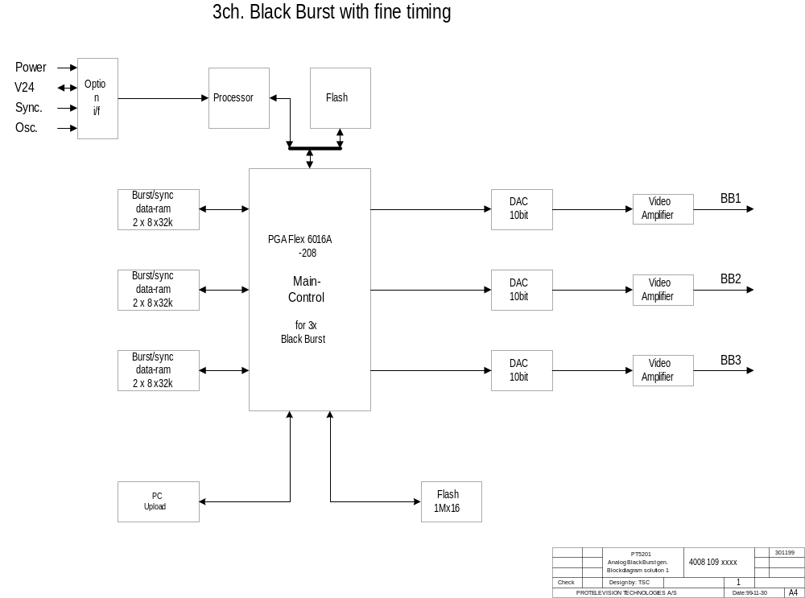

Block Diagram Description
The block diagram consists of:
- One Processor systems with a flash PROM.
- One PGA (Main control) with logic to control 3 BlackBurst outputs. Sync and BlackBurst data in flash and ram.
- Dac’s
- Output drivers for the BNC connectors.
- Upload

1. The processors handle the communications with the master processor (ControllerCard), e.g. commands, and controls the 3 blackburst generators.
The processor-system will be a 16-bit system to meet the new requirements.

2. The PLD (Main control) contains logic to control 3 BlackBurst generators with the following main functions:
- communicate with the controller-system.
- running data sequencer for the dac’s.
The principle of Main control is to load burst and sync data from the flash into the ram’s. Under initialization of the balckburst-generator an init-load routine will fill the sync-ram’s. The PLD then will be loaded with the generator-data and load the burst-data after it has been used the Main control will start refill the burst-ram’s with the new burst-data for the next line. The sync data will stay the same as long as the blackburst-generator is powered on.

3. For each BlackBurst channel the dac are 10 bit’s to maintain the accuracy from former balckburst generators

4. The video-amplifier modules consist of two op-amps with a filter and an output circuit to obtain 75 ohm on the BNC outputs.

5. To upload the PLD from a PC there is a plug

Color Bar Generator – Analog & SDI
Prepared by: NHa & KEn

Main Functions, HW
Generating a black burst or a color bar signal. The signal should be timeable within the whole color sequence, PAL: ± 4 fields, NTSC ±2 fields. Besides the color bar signal some other simple test signals can be generated

The generated signal should also be available as a Serial Digital signal, 270 Mbit/s This signal can have embedded sound. The PCB will be prepared for EDH code insertion, but to keep the prize low this function is probably not to be used.

Block Diagram, HW

Clk Line Color framing

Databus SDI out
SDI serializer
Pattern & sound generator

(from master
Controller)
Data bus tranciever

Composite encoder
Composite out
Address bus
Sound and video RAM
Address bus tranciever

Block Diagram Description, HW

From Clk, line and colorframing pulses the Pattern & sound generator is able to generate a horizontal line. With two bits from the (master) controller, one of four vertical lines can be selected. These four lines are used to generate a black signal.

This signal is fed to a SDI serialize and a composite encoder. The two outputs will then have the same timing and system (625 lines or 525 lines).

If needed, the controller can load sound data and an active video pattern in a RAM. These patterns can then be added to the generated black signal. Data are added to the black signal by help of some “vertical” control bits from the controller.

When pattern and/or sound must be changed, by user command, new data can be loaded into the RAM. When data are loaded, a black signal is generated. This takes about 160 ms.

This generator will have the same possibilities as PT 8639 with an added composite output.

Main Functions, SW
The HW is built upon the concepts known from the PT8609/39 generators used in the PT5210/30 series, which indicates that the software will be modified from these generators in order to make it work in the master controller software.

The basics of the software is to update some control signals to a PLD which in turn handles the generation of a specific line. This update should be performed for almost every line, i.e. continously at a rate of app. 64μs.

The above implementation has been chosen, as it is the most cost effective way of generating the signals. It is possible to implement counters etc. in PLDs, but that would increase the size of the PLD, hence making that component more expensive and more difficult to implement. Another possibility is to use an extra inexpensive processor with built-in code memory, dedicated to the generation of a black burst. This merely introduces an extra cost for the component and the development/maintenance of some new stand-alone software. Finally the signal generation could be totally redesigned, but as of yet no new inexpensive and revolutionary design has emerged.

One major difference from the existing SW layout in the PT8609/39 is the lack of a hardware counter, which have to be implemented in software. Only 3 timers/counters are available in the XA controller, and since the implementation of the master controller software requires two serial ports, each having its own baud rate generator, i.e. timers, only one timer/counter is left for the Color Bar generator. The two serial ports are one for the external RS232 interface and one for the internal serial communication.

Block Diagram, SW

Delay line

Pattern
generator
Field pulse
Line pulse
Line pulse
Pattern start

Block Diagram Description, SW
Whenever a field interrupt occurs a ”delayed line counter” is reset in order to delay the generated line according to the user settings. This counter in incremented through a line interrupt which interrupts the system for app. every 64μs. The line interrupt will also write the next line to be displayed to a PLD.

The pattern generation is based upon a black burst signal with audio, which resides in code memory, and a pattern, which is downloaded to user memory during power-up and/or user selection. The appropriate control signals are loaded to a PLD for every line that has to change. The PLD will then generate the correct signals used to generate the complete pattern based upon the contents of some signal memory.

AES/EBU Generator
Prepared by: PF.

Main Functions
The audio generator has to generate digital audio according to the AES3-1992 norm. The signal is outputted on a XLR connector (110 Ω / balanced).
The generator also outputs word clock (HCMOS terminated into 75 Ω).
The generator outputs 1 kHz stereo tone, silence and word clock. There are 8 different levels selectable from the master processor.
The audio system is phase and frequency locked to the video (PAL or NTSC).
The audio system is timeable in step of 0.8us up to 20us.

Block Diagram

PLL

Audio data
27MHz 6.144MHz

Control and
timing logic
Word clock
driver
BNC

Audio/video
sync logic
Video sync

XLR output
driver
XLR
Control

Block Diagram Description
PLL:
The purpose of the PLL is to convert the 27MHz ref clock to 6.144MHz, which is the clock for the audio generator.

Audio/video sync logic:
The purpose is to phase lock the audio signal to the internal video sync signals. The timing only relates to the audio sample timing, which is 20.8us.

Control and timing logic:
The PROM with audio data is controlled from this logic.
The audio signal can be timed from 0.8us to 20us in step of 0.8us.

Output drivers:
The word clock output is a HCMOS driver with an output impedance of 75 ohms. The XLR output uses a pulse transformer to obtain a balanced output with an output impedance of 110 ohms.

Remote interface

Main Functions

Block Diagram

Block Diagram Description

PC Remote Software
PC software written in LAB-Windows will be developed for remote control of the PT 5201.
The software will be delivered together with the instrument on a CD-ROM. This CD-ROM will contain the manual as well.

Main Functions
The PT 5201 will be delivered to the customer with dedicated PC software for operating of the instrument.
The software and the PC is only needed when changes are to be performed considering configuration, or if more specific status information are needed than can be read on the front panel LEDs. Daily operation including power on/off does not require the PC. A standard RS232 interface cable is used between the PT 5201 and the PC.

Block Diagram

Block Diagram Description

Power supply
Prepared by HCM.

To minimize power consumption in the circuits in PT5201 the greatest possible number of components will be supplied on 3,3V. Some vital IC’s demand 5,0V and others –3,3V.
These power requirements are meet by using an, internal, main 3,3V switched mode power supply, from which the secondary voltages will be generated. Both 5,0V and –3,3V are made from dedicated DC-DC converters, which are placed on the main PCB.

Cabinet & Mechanics
Prepared by HCM.

The cabinet will be made as a tree piece folded aluminum chassis. Due to high volume and complexity of the rear and front plate, a custom design solution is most cost effective. Front plate and top cover will be painted in PTV color. Bottom cover integrated with rear plate, will have the plain aluminum surface. Text on rear plate will be printed on chassis, as on PT5210/30.
Logo and text for the front plate can either be a polycarbonate film to glue on or, printed as part of the silk print. Choice of solution will depend on cost and to make an eventual future OEM branding easy.
Rack mounts can be made simple and will have finish like the front plate.

The mechanical concept for PT5201 is based on the philosophy, as cheep and few components as possible. For easy assembling are all electronic components, connectors and LED’s are mounted on a single PCB and the built in power supply has onboard power inlet.
Cooling of circuits are handled by traditional convection, and heat conduction trough PCB ground plane to BNC connectors and staynuts.

New Components and Technologies
Her beskrives nødvendige nye komponenter og anvendte teknologier - ikke blot kredsløbsmæssigt men også produktionsmæssigt.

Where price and/or performance can justify the introduction of a new component or technology this is likely to be chosen since PT 5201 is running in large production quantities and is very prize sensitive.

3.3V logic IC’s and components will be used intensively as this is the market standard the coming years assuring that prize, delivery performance, and power consumption will be optimal.

PLD
It is planned to use a common 144-pin PLD for the analog color bar / SDI / AES generator of type Altera. The price for the Altera PLD is appr. 250 DKK. Xilinx has a PLD with 12% more logic cells at a price of appr. 125 DKK, which can replace the Altera PLD. The Xilinx PLD development software costs 95$ and should be easy to use.

Flash PROM’s
Flash prom’s will be used to make data reprogramable.

Complex components
Complex components will increase the risk of obsolete components, but will decrease the costs considerably.
E.g. the 3 video-dac's are placed in one chip.

Multimedia chip
Due to the low target price, we have decided to use a dedicated composite modulator chip (multimedia IC). The price for this solution is about 10 % of the modulator used in e.g. PT 8631.

The problems with the new solution are, that the performance is slightly lower than what we are used to, but should be sufficient for this generator. (Examples: resolution 8 bits, frequency response is specified to 5 MHz with a rapid roll of, and response is specified as +0.3 dB/-0.5 dB).

Another problem is that it is a consumer type. It can have a shorter lifetime than our equipment. If it becomes obsolete, the board has to be redesigned.

Development Time & Cost
Her angives det estimerede ressourceforbrug til gennemførelse af de planlgte udviklingsfaser:
Interne udviklingstimer, externe konsulenttimer, udviklingsmaterialer herunder prototyper opsplittet på faser.
Please refer to the spreadsheet included in appendix 2
The highest priority for the development group is to deliver a functional model to the NAB exhibition in April 2000 and to assure that instruments can be delivered to customers no longer than 2-3 month later.

The present estimate, according to the spreadsheet, covers the NAB prototype and implementation of minor changes, which can be done by correction of documentation such as diagrams, parts list, and PCB layout without production of new models before the actual pilot production. If larger error must be corrected a new estimate will have to be made accordingly.

Test equipment Time & Cost
Estimeret tid og omkostninger til udvikling af testudstyr. Opdeles på testudstyr til underleverandører og til FMS.
Please refer to the spreadsheet included in appendix 2

Production Cost
Estimeret produktionsomkostning pr. stk. i de forventede kvantiteter:
Materialepris, montageomkostning, testomkostning
The pilot production as well as the normal production takes place partly at external sub-vendor(s) and partly at PTV. GPV has been suggested for the external part delivering the SMD mounting service as well as mounting of parts in the cabinet. Since this cooperation is new some run-in difficulties may occur and much attention should be paid to the process to minimize the risk.

The production cost is based on a yearly production quantity in the order of 2000-2500 pieces of equipment. The estimate can be seen in appendix 2
It should be noted that the prize of the cabinet and mechanics is our own guess (and hope). Next step will be to involve the external supplier of the cabinet.

Appendix 1 - Front & Rear plate layout

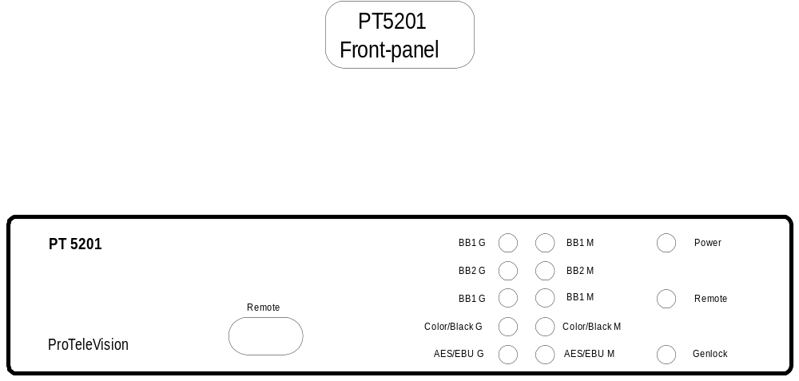

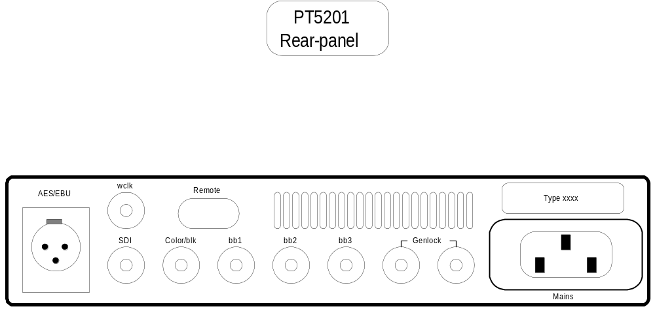

Appendix 2 - Estimate of development and production cost

